1. Install ubuntu server on your VM.
2. Choose bridged network adapter with enp0s3 type.

3. Fire up your VM. Wait until your ubuntu fully loaded and the log in. After login you will see IPv4 address for enp0s3 which is going to be used for ssh connection.

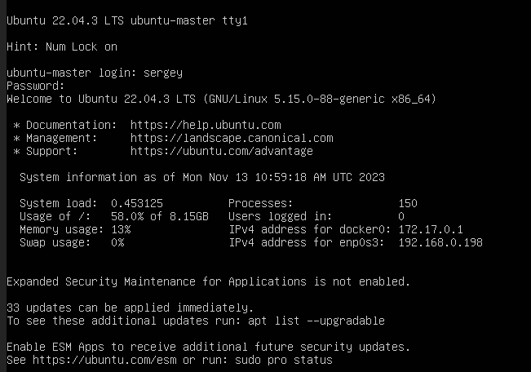
4. Open terminal on your real machine and type:

ssh someusername@192.168.0.198.

Note that: someusername is user on your VM.

